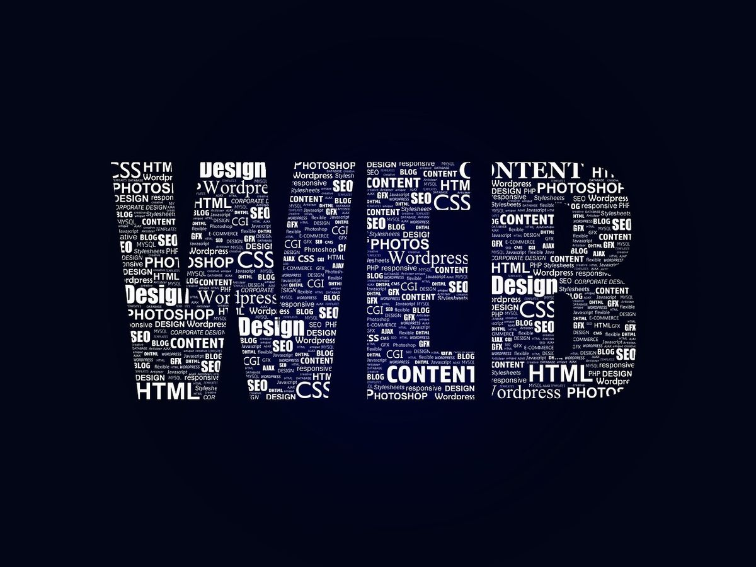
web development
(WEDE 5020)
Proposal 2
Karabo Jjaone
ST10485247
Table of Contents
1. Organisation Overview 2
2. Website Goals and Objectives: 3
3.Current Website Analysis 4
4. Proposed Website Features and Functionality: 5
5. Design and User Experience: 6
6. Technical Requirements: 8
7. Timeline and Milestones: 9
8.Budget 10
9. References 11

Organisation Overview

Name: South African Business Council

History of Organisation:
Established in 2019, we are proudly a level one, black owned, female operated and managed organisation. Our expertise includes specialists from various fields who bring combined industry experience of 100+ years together, so that we may offer value added services to our target market.

Mission and Vision Statements:
Mission: Create employment, reduce gender based violent crimes, eliminate period poverty and to create a sustainable business ecosystem for all those that are in need.
Vision: Make positive change within the South African business sector. Create wealth, reduce poverty and crime. To be remembered as a trusted, reliable and reputable partner.

Target Audience:
- Small business owners
- Entrepreneurs
- Youth


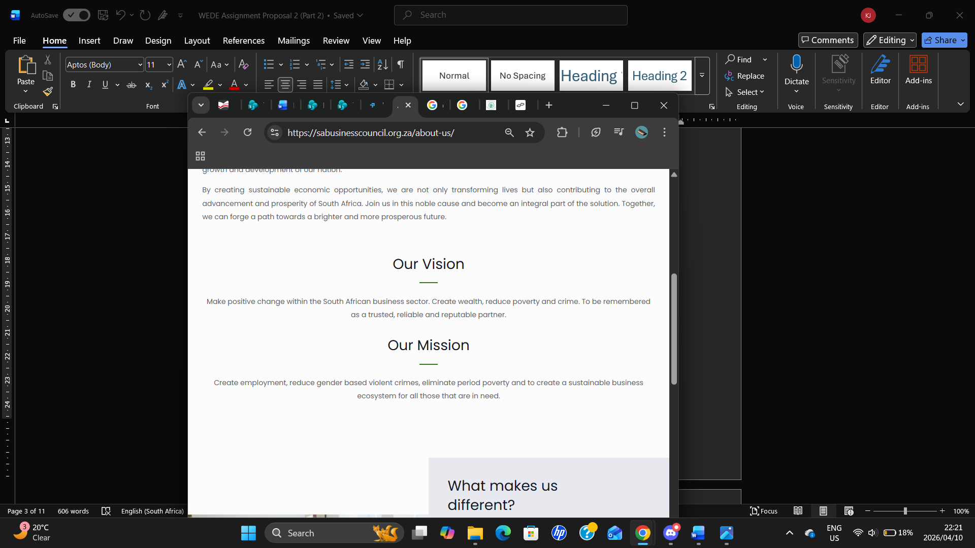
(SA Business Council, 2023)

2. Website Goals and Objectives:

- Raising awareness: Increase page views, time on site, or content shares
- Recruiting volunteers: Increase sign-ups or completed application forms
- Building trust: Improve testimonials, impact pages, transparency reports, and user engagement (Serious Otters, 2025)
Present key performance indicators (KPIs) to measure success.
Customer (Satisfaction & Loyalty)
- Measures customer loyalty and likelihood to recommend
- Net Promoter Score (NPS)
- Customer satisfaction rating (e.g., survey score out of 5)
Financial KPIs (Profitability & Growth)
- Percentage of revenue remaining after all expenses
- Net Profit Margin (%)
- Revenue growth rate (%) (On Strategy, 2024)

3.Current Website Analysis

Strengths:
- The website explains its focus on job creation
- Users quickly understands what the organisation is about.

Weaknesses:
- Some information on the navigation bar may not be easy to find
- Design of website may feel simple compared to modern websites

Areas for improvement based on the weaknesses identified
- Add a search bar
- Expand Content
- Improve User Experience

4. Proposed Website Features and Functionality:

Homepage: It allows users to easily navigate to all other pages on the website.
About Us Page: Shares the organisation’s history, mission, and background in a clear and well-structured layout to help users understand who they are.
Programmes Page: Gives detailed information about each programme, including what they do and how they benefit the community.
Contact Us Page: Allows users to get in touch with the organisation through contact details or a contact form. (Zoho, 2023)

5. Design and User Experience:

The website has nonprofit style aesthetic focused on delivering information.

Colour Scheme:
- Deep blue: trust and authority
- Warm orange: energy and calls-to-action
- Soft grey: neutral background
- Green: growth, sustainability, and impact
Typography:
Heading font: Poppins
Body font: Open Sans
Hierarchy: H1: Bold, (32–40px)
Layout:
- Strong headline
- Visual storytelling:
- Photos of beneficiaries

Add clear menu structure:
Layout
- Bullet points
- Short sections
- Highlight boxes

Colour Scheme
- Blue: trust sections
- Orange: CTAs
- Green: impact/success

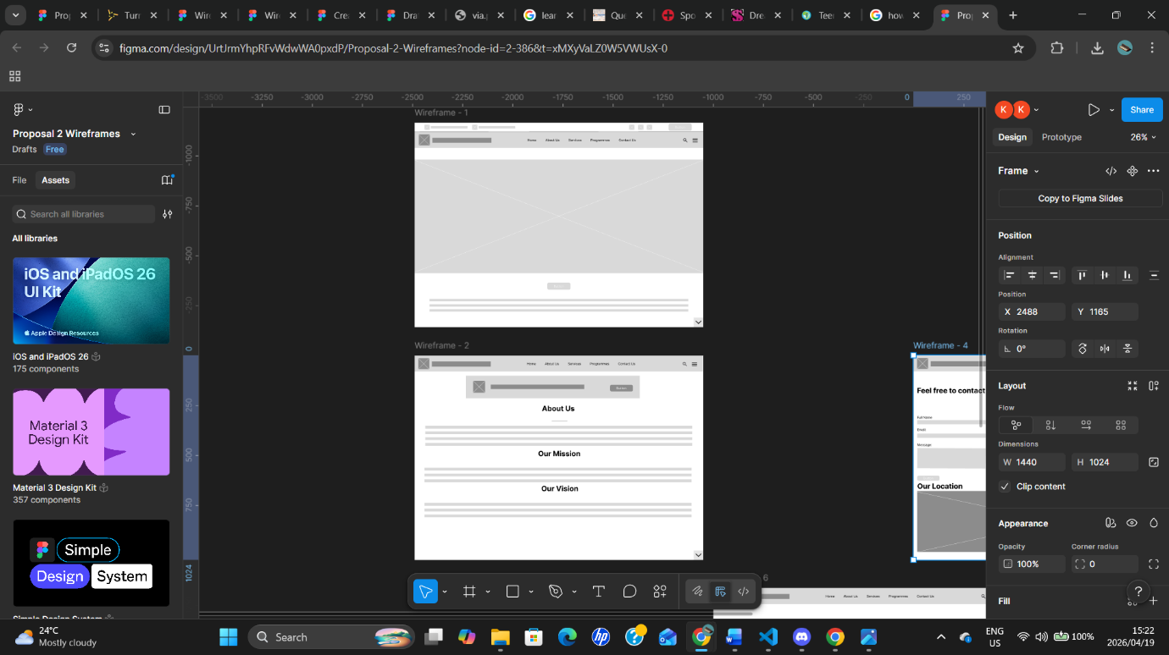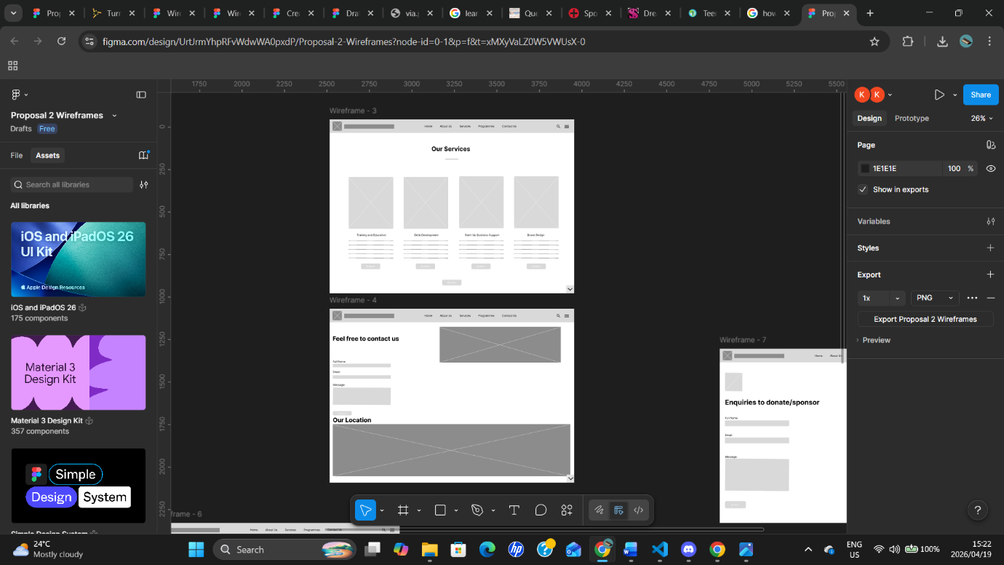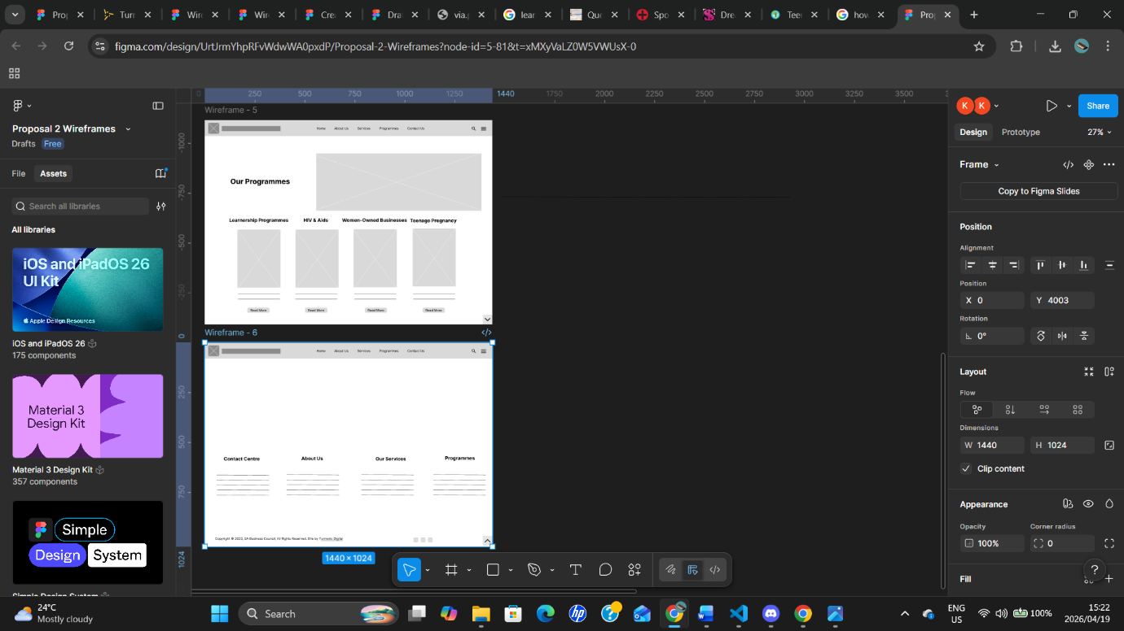
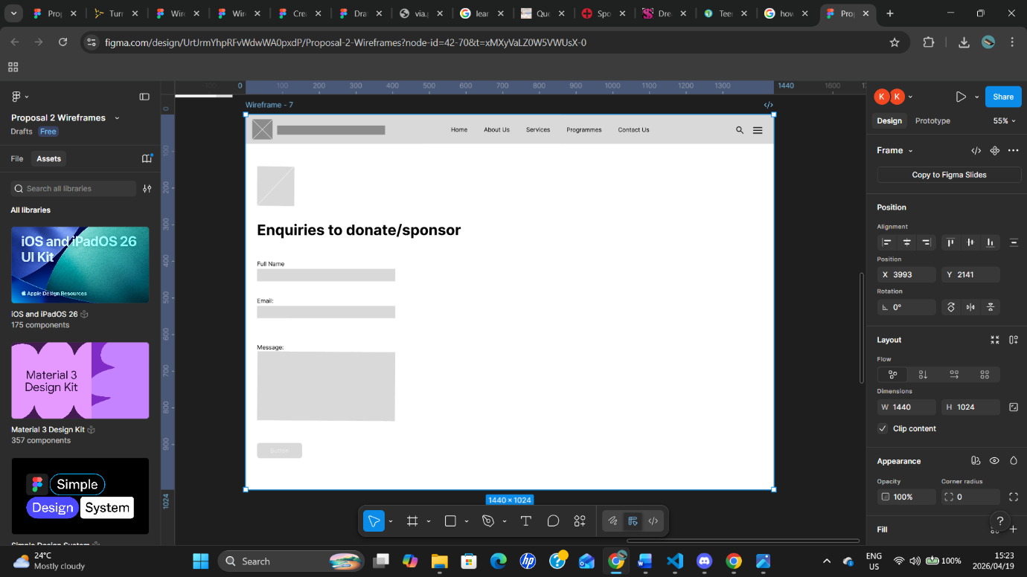

https://www.figma.com/design/UrtJrmYhpRFvWdwWA0pxdP/Proposal-2-Wireframes?node-id=0-1&t=lr3DtfD3iyy9JSqG-1

6. Technical Requirements:

Hosting Requirements
- Shared Hosting: The most affordable option, where multiple sites share server resources. (One Each Technologies, 2026)
Domain Name Requirements
- .org: The global standard for nonprofits, signalling credibility and a mission-driven focus. (tld-list, 2015)
Programming Languages & Frameworks.
- HTML: Defines the structure of the site.
- CSS: Used for styling.
- JavaScript: Adds interactivity. (Coventry Domains, 2019)

7. Timeline and Milestones:

  - PROJECT TIMELINE (APRIL)
Week 1: Planning & Proposal (1–12 April)
- Develop and submit research proposal
- Identify project objectives, scope, and requirements
- Conduct preliminary background research

Week 2: Review & Research (13–20 April)
- Receive and review feedback on proposal
- Communicate with lecturer for clarification and improvements

Phase 2: Research & Content Gathering (15–18 April)
- Collect relevant content
- Organise research materials

Phase 3: Initial Development Setup (17–20 April)
17–18 April: HTML Structure Development
- Create basic HTML layout
- Establish semantic structure

8.Budget

Development Budget:
- Basic site: R5000-R10000

Hosting Budget:
- Hosting: R100-R600 Per month

Maintenance Budget:
- Maintenance: R300-R800 Per month
(growth pulse media, 2026)

9. References
Conventry Domains, 2019. HTML, CSS and the Languages of the Web. [online] Available at: https://coventry.domains/learn/languages-of-the-web/ [Accessed 4 April 2026]

Growth Pulse Media, 2026 Web Design Pricing South Africa: Complete Cost Guide 2026, [online] Available at: https://www.growthpulsemedia.co.za/web-design-pricing-south-africa [Accessed 9 April 2026]

On Strategy, 2024. KPIs Meaning + 27 Examples of Key Performance Indicators. [online] Available at: https://onstrategyhq.com/resources/27-examples-of-key-performance-indicators/ [Accessed 4 April 2026]

One Each Technologies, 2026 The Best Website Hosting for Nonprofits with OneEach, [online] Available at: https://oneeach.com/solutions/hosting [Accessed 9 April 2026]

SA Business Council, 2023, [online] Available at: https://sabusinesscouncil.org.za/ [Accessed 8 April 2026]

Serious Otters, 2025, [online] Available at: https://www.seriousotters.com/blog/digital-marketing-goals-audience-nonprofits-social-enterprises/ [Accessed 18 April 2026]

Tdl-list, 2015 Domain registrations, [online] Available at: https://tld-list.com/tld/org.za [Accessed 9 April 2026]

Zoho, 2023 Creating a website that engages: The key functionalities you need to include. [online] Available at: https://www.zoho.com/en-au/tech-talk/functionalities-of-a-website.html [Accessed 9 April 2026]

